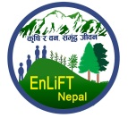
EnLiFT: Enhancing livelihoods and food security from agroforestry and community forestry in Nepal
ACIAR FST/2011/076

Response to EnLiFT Mid-Term Review

Ian Nuberg, with contributions from EnLiFT Executive Team:
Krishna K Shrestha, Naya S Paudel, Hemant Ojha, Edwin Cedamon
15 April 2015
The EnLiFT project undertook an early in-country Mid-Term Review (MTR) on 12-22 January 2015. A comprehensive report of the review process was received on 22 February from the review team, Tony Bartlett and Don Gilmour. The project team has taken almost 2 months to determine our response to the MTR because another cycle of discussion was required since then Action Research planning meetings that immediately followed the review.
The EnLiFT executive team, indeed the whole project, is very grateful for the time and effort that the MTR team has invested in our project. We trust this response is complete and satisfactory and that ACIAR will approve our decisions.
This document presents in order:
- Revised project structure and description of sub-theme work plans
- Revised outputs table
- Responses to specific issues and recommendations.

1 Revised project structure and description of sub-theme work plans
For the past two years the original project structure of objectives, activities and outputs was felt to be too ambitious for the resources available. Also we have learnt a lot in this time, and following an action research approach it is appropriate for us to undertake a major reflection of the project structure. Hence, the request for an early MTR.
The three project objectives for the Agroforestry, Community Forestry and Under-Utilised Land research themes remain unchanged. The reflection process to streamlining and focus the project by looking for “flagship” activities was partially successful. The new statement of sub-themes here and attendant outputs has effectively focussed the project on a relevant and deliverable target. However, the project is not necessarily more ‘streamlined’; we still have seven research sub-themes and 52 Outputs, which is more than we started with in the original plan!

The new research sub-themes with brief aim statements are:

Agroforestry research theme
- Market-oriented field interventions
Aim: to improve our understanding of the institutional environment affecting markets of agroforestry products. It also concerns the practical implementation of agroforestry interventions, which include both growing systems and commodity markets, at the 6 priority sites

- Impact of agroforestry interventions
Aim: to gather and analyse both quantitative and qualitative information to determine the impact of interventions in the farm-forest system. This includes biophysical data of agroforestry production systems and qualitative information of the impact of interventions on women on the 6 research sites. The modelling activity will integrate biophysical and social (e.g. from Inclusive CF sub-theme) information to estimate the potential impact of EnLiFT innovations further field in the Mid-Hills

Community forestry research theme
- Inclusive community forest planning
Aim: Exploring link between regulatory framework and community forest planning practices and understand dynamics of inclusive forest management and local level planning in the changing contexts.

- Active and equitable forest management
Aim: to catalyze active and equitable forest management and silvicultural practices through the establishment of demonstration plots and contribute to participatory silvicultural technology by gathering data from community forest management trials. This will also provide information that will be used in the EnLiFT model in the Impacts sub-theme.

- Market-responsive community forest institutions
Aim: to explore and catalyze market-responsive community forestry institutions by experimenting the collaboration between the private sector and community forest user groups; and to facilitate participatory market appraisal and business-readiness with CFUGs

Under-Utilised Land research theme
- Under-Utilised Land
Aim: to disseminate our understanding of drivers and dynamics of UUL and to develop a typology of different types of UUL and management options for their productive and equitable use. The UUL activity is the most heavily reduced from its original plan.

Across all research themes
- Research-Policy interface
Aim: to directly engage with policy actors in the fields of community forestry, agroforestry and under-utilised land to identify policy and institutional constraints to food security. This sub-theme embraces all three research themes

2 Revised Outputs Table for ACIAR Reporting
This table presents the revised and re-numbered Outputs Table along with the Outputs from the original table that have been deleted. Some orphan outputs are re-written in new outputs.
Research  sub-theme |  | Activity |  | New Outputs | DUE DATE |  | Orphaned Original Outputs & due dates
Objective 1: To improve the capacity of household based agroforestry systems to enhance livelihoods and food security
1]  Market-oriented field interventions | Institutional mapping of AF |  | O1: Publication on “Drivers of farming systems adaptation, farmers’ existing agroforestry practices, and perceptions of limitations to their livelihoods across six agroecological settings in the Middle Hills region” = KPI for 2014/156 |  |  | JUN 2015 | O5: A policy discussion paper highlighting links between key governance variables and agroforestry contribution to livelihoods APR15  O6: A scientific paper demonstrating how prevailing policy, institutions and governance shape and determine the livelihoods and food security outcomes of agroforestry APR17  O17: Recommendations for institutional and policy arrangements to enhance livelihoods through agroforestry JAN18  O13: 6 pilot sites of improved commercial agroforestry systems for demonstration purposes APR16  O15: A resource book and other extension products for farmers interested in new agroforestry and market opportunities OCT17  O16: Farmer-to-Farmer training of improved agroforestry systems JAN18  O18: Recommendations for service provision to further the enhancement of livelihoods and food security from agroforestry JAN18
 |  |  | O2: Report of Participatory Market Chain Appraisal of the full range of AF products (includes market trends and growing markets) |  |  | JUN 2015
 |  |  | O4: Report of training and outputs of participatory business plans of priority products for each of 6 sites |  |  | DEC 2015
 |  |  | O5: Scientific paper characterizing AF formal & informal institutions that can catalyse AF products marketing and their change over time. |  |  | DEC 2015
 | Priority product implementation |  | O6: 1st cycle report of commercial plantings |  |  | DEC 2015
 |  |  | O7: 2nd cycle report of commercial plantings |  |  | DEC 2016
 |  |  | O8: Extension package to facilitate expansion of innovations |  |  | JUN 2017
 |  |  | O9: Scientific paper AF interventions to enhance livelihoods and food security |  |  | DEC 2017
2]  Impact of agroforestry interventions | Agroforestry trials |  | O10: Progress report of agroforestry trials  O11: Scientific paper(s) on performance of fodder hedgerows, fodder trees, Taxus and nursery plantation for change in livelihood and food security |  |  | DEC 2016  DEC 2017 | O10: Scientific publication quantifying nutrient and energy flows through the farm-forest system. JAN16  O11: Scientific publication establishing the biophysical basis for sustainable agroforestry innovations APR18
 | EnLiFT Model |  | O12: Scientific paper quantifying factors determining an index of food security in the farm-forest system. |  |  | DEC 2015

Research  sub-theme |  | Activity |  | New Outputs | DUE DATE | Orphaned Original Outputs & due dates
Impact of agroforestry interventions  continued |  |  | O13: Scientific publication establishing the biophysical basis for sustainable agroforestry innovations |  | DEC 2017
 | Women’s Voices |  | O14: Paper on Women’s perspective on research for development |  | DEC 2017

Objective 2: To improve the functioning of community forestry systems to enhance equitable livelihoods and food security of CFUG members.
3]  Inclusive community forest planning | Exploring link between regulatory framework and CF planning | O15: Process report on Inclusive community forest planning (FA leads, UNSW contributes) | DEC 2015 | O20: Discussion paper outlining progressive and regressive links between a) critical community level dynamics and b) resource management, access and utilization APR15  (final draft still being delivered)  O21: A scientific paper highlighting key patterns of livelihood outomes from community forestry in the study sites APR16  O23: Workshop proceedings with recommendations for researchable forest management institution and practices, and indications for research to lessen constraints on best practice forest management APR16  O24: O24: A scientific paper identifying patterns of institutional innovations in community forestry systems  O27: Publication of institutional innovations in CF systems
 |  | O16: Process report including preliminary discussion paper on Inclusive community forest planning (FA leads, UNSW contributes) | DEC 2016
 |  | O17: Policy Brief: How regulatory framework and local level development governance shape CF planning in Nepal (FA leads, UNSW contributes) | DEC 2016
 |  | O18: Journal Paper: “Inclusive community forest planning: How regulatory framework and local level development governance shape CF planning in Nepal” (UNSW leads, FA contributes) | DEC 2017
 | Understanding interface between CF planning and local level planning | O19: Process report on how local level planning accommodates CF management (FA leads, UNSW contributes) | DEC 2015
 |  | O20: Process report including preliminary discussion paper on how local level planning accommodates CF management (FA leads, UNSW contributes) | DEC 2016
 |  | 021: Policy Brief: on interface between CF planning and local level planning (FA leads, UNSW contributes) | DEC 2016
 |  | O22: Journal Paper: “CF innovation pathways for food security” (PC/FA leads, UNSW contributes) | DEC 2015

Research  sub-theme | Activity | New Outputs | DUE DATE | Orphaned Original Outputs & due dates
4]  Active and Equitable Forest Management | Silviculture demonstration, monitoring and measurement | O23: Silvicultural demonstration plots established on 3 sites in Kavre and 3 sites in Lamjung with a series of extension activities (UNi Adel leads, FA and UNSW contributes) | DEC 2015 | O33: Report of results of silviculture trials in community forests APR17  O34: 6 pilot sites with functioning models of community forestry practice for demonstration purposes APR17  O35: A resource book and other extension products for community forest user group (CFUGs) members on best practice forest management, commercial and institutional arrangements that increase the level and equitable access to benefits from community forests APR17  O36: A practitioner’s guidebook to facilitate APR17  O37 Scientific paper describing the refined adaptive action research approach to facilitate community forestry innovation including its challenges, APR18  O38: Scientific paper analyzing the links between contexts, processes, and outcomes of adaptive action research on food security and equitable livelihoods APR18
 |  | O24: Technical paper from re-measurement of silviculture plots of Nepal Australia Forestry Project (Uni Adel leads, FA contributes) | DEC 2015
 |  | O25: Process report on silvicultural research report #1 (FA leads, Uni Adel contributes) | DEC 2015
 |  | O26: Process report on silvicultural research report #2 (FA leads, Uni Adel contributes) | DEC 2016
 |  | O27: Policy discussion paper summarising key lessons from the active and equitable forest management action research highlighting key policy recommendations (Uni Adel leads, FA and UNSW contributes) | JUN 2017
 |  | O28: Resource book for active and equitable community forest silviculture (FA leads, Uni Adel and UNSW contributes) | DEC 2017
 |  | O29. Journal paper: Silvicultural innovations for food security (Uni Adel leads)  O30. Journal paper: Catalyzing active and equitable forest management: Practices and lessons (UNSW and UniAdel lead) | DEC 2017

Research  sub-theme | Activity | New Outputs | DUE DATE | Orphaned Original Outputs & due dates
5]  Market responsive CF institutions | Private sector identification and participation | O31: Report of wood manufacturing companies searched, identified, approached and invited to participate in the planned participatory market appraisal; along with Memoranda of Understanding | JUN 2015 | O32: Report on a survey of the early impact of the project in the Middle Hills JAN16
 | Participatory market appraisal & business literacy workshops | O32: Report on PMAs and business literacy workshops held at 6 priority research sites | JUN 2016
 |  | O33: Research report analyzing timber market value chain, regulatory constraints opportunities and challenges facing the Chaubas sawmill (SN leads, FA, UNSW and UniAdel contributes) | DEC 2015
 |  | O34: Scientific paper based on the review of lessons on community-private sector partnership in natural product business from Chaubas and other relevant cases (UNSW leads, UniAdel, SN and FA contributes) | JUN 2016
 |  | O35: Short illustrated handbook on how to compile business plan or make your own CFUG business scheme. | DEC 2017

Objective 3. To improve the productivity of, and equitable access to, underutilised and abandoned agricultural land
Research  sub-theme | Activity | New Outputs | DUE DATE | Orphaned Original Outputs & due dates
6]  Under-Utilised Land | Sharing and communication | O36: A scientific paper explaining genesis of under-utilised agricultural land & Household case studies of land access, use and abandonment (UNSW leads, UniAdel and UUL team contributes) | DEC  2015 | O43: A scientific paper explaining genesis of under-utilised agricultural land DEC 2014  O44: Report on policy and legal environment of land access with particular reference to the 6 study sites, along with the identification of opportunities for action research innovations APR17  O46: Policy brief with recommendations on how to encourage the productive use of under-utilised and abandonned land, and how the benefits of this use is equitably distributed APR17
 |  | O37: Report on UUL based on previous findings to share with field researchers project research partners, district level line agencies | DEC 2015
 |  | O38: Report of District level workshops to disseminate the knowledge generated so far and use it as platform to discuss ways to identify management options | JUN 2016
Under-Utilised Land  Continued | Developing UUL typology and management options for productive and equitable use | O39: Report outlining specific action research threads along with agreements on planned land management and institutional experiments | DEC 2016 | O47: A scientific paper explaining on how and why policy and institutional regimes produce (or do not produce) fallow land APR17  O40: Report on Training opportunity for Institute of Forestry students  O41: Report describing the drivers and dynamics of land use in the Middle Hills  O42: Household case studies of land access, use and abandonment  O48: Workshop proceedings with a short-list of feasible options for under-utilised and abandoned land APR15  O49: Report outlining specific action research threads along with agreements on planned land management and institutional experiments APR15  O50: Report of the success of integrated land management options APR18  O51: A scientific paper analysing the context, process, and outcomes of the innovations APR17
 |  | O40: Report on progress towards success of integrated land management options | JUN 2017
 |  | O41: Policy brief with recommendations on how to encourage the productive use of under-utilised and abandoned land, and how the benefits of this use is equitably distributed | DEC 2017

Over all objectives

Research  sub-theme | Activity | New Outputs | DUE DATE | Orphaned Original Outputs & due dates
7]  Research-Policy Interface | Policy workshops,  Data analysis  Literature review  Paper writing | O42: EPL synthesis report and Blog # 1 | JUN 2015
 |  | O43: Discussion paper on EPL framework outlining steps, process, tools and strategies (UNSW Leads)
 |  | O44: Policy workshop report (PC leads) | DEC 2015
 |  | O45: Policy and regulatory analysis report on CF (PC leads)
 |  | O46: Policy workshop report (PC leads) | JUN 2016
 |  | O47: Scientific paper on EPL methodology/framework capturing learning from workshop reports (UNSW leads)
 |  | O48: Policy Workshop report (PC leads) | DEC 2016
 |  | O49: Policy and regulatory analysis report on CF (PC leads)
 |  | O50: Scientific Paper on land policy and food security (UNSW leads, PC and UniADEL contribute)
 |  | O51: Policy Workshop report and Blog #5 (PC) | JUN 2017
 |  | O52: Overall scientific paper on science-policy interface (UNSW leads, PC contributes) | MAR 2018

3 Responses to specific issues and recommendations
There were 12 specific issues from the MTR repeated here in blue italics followed by our response.
- The project team should consider identifying a relatively small number of “flagship” high priority activities and associated outputs that are considered “must do” to answer the research questions and to achieve the most substantial outcomes from project activities.
The planning workshop on 22/01/15 aimed to re-conceive the priority activities for the project in an effort to build focus and efficiency in our activity. The concept of “flagships” was used as a conceptual handle, but we have since dispensed with that term because it is a misleading metaphor. A “flagship” is the highest profile activity among a group, or “flotilla”, of research activities. The research activities that remain in the project, do so because they are all important for the delivery of an integrated interdisciplinary project. No activity trumps another activity. We have settled on the term sub-themes to maintain the activities primary connection to the 3 themes of Agroforestry, Community Forestry and under-Utilised Land.
The resultant sub-themes are shown in Table 1. Whether 7 sub-themes is a “small number” is debatable, but they are all arguably “must do” activities to achieve the 3 project objectives which have not been changed from the original.
- A clearly articulated plan for the agroforestry research needs to be developed and communicated to ACIAR, so that it is clear what the interventions are at each site and what value chain activities will be conducted to support these interventions.
We agree that the agroforestry research was not well articulated at the MTR. The AF team has met subsequently and produced the plan provided in Appendix 1. We trust this is a satisfactory explanation of their plan. Please note the comment on #4 with respect to the value-chains aspect.
- The planned participatory action research on community forestry and value chains for the six Category A research sites needs to be developed and communicated to ACIAR.
Effort has already been exerted on revitalisation of Chaubas mill as a case study for developing community-based timber enterprise and institutional arrangements needed for this to function more effectively. This will be an entry point for the participatory action research on market and value-chain development which covers contemporary institutional and silvicultural issues. The key area of exploration for Chaubas milling is looking at possibility for a public-private business model in community forestry. In addition to Chaubas mill, in collaboration with the inclusive planning and active and equitable silviculture initiatives of the CF Theme, participatory market appraisals and workshops will be conducted for the 6 research sites covering 24 CFUGs. The aim of the participatory market appraisal is to establish linkages between the timber and other forest products producers (CFUGs) and players in the value chain that will be necessary for the CFUGs in developing their business plans for forest-based enterprises. A strong framework for analysing market responsive CF institutions have already been developed. The above activities and work plan will be designed and implemented within the framework.
The specific work plan for Market-Responsive CF Institutions is given in Appendix 3.

- Enhanced effort is required on the value chain and market research under Objectives 1 and 2 to enhance the economic benefits that flow to the farmers and CFUGs.
The value chain and market research has been poorly coordinated, and it is difficult to see how this can be rectified. There are three highly capable, but apparently highly individualistic, senior researchers working in this area. Each of them has delivered good results independently, especially in the AF markets research. But as a team they do not communicate well, despite the best of the project leader’s efforts to remind them to do so. It is our opinion that the ICRAF specialist in this area should be taking a stronger and timelier involvement in bringing the markets team together. There has been some effort in coordination of this team since the MTR but we are still to see the fruits of this. It may be necessary for ACIAR to diplomatically intercede on our behalf to ensure this change maintains its momentum.
- A planned approach for activities at category C sites and in satellite districts needs to be developed and communicated to ACIAR, that considers available resources and balances community expectations with achieving appropriate levels of impact from both primary research sites and the additional sites to support scaling up goals.
As can be seen in the Outputs table we have contracted our outputs from delivering to secondary (ie 3 CFUGs in each site) and satellite sites (ie in Kaski and Sindhupalchowk dsitricts). The time to implement all the demonstration trials at priority sites has also been extended (e.g. CF demonstrations at Lamjung have been delayed until 2016). However, we expect that both the AF and CF trials at the priority sites will have impressive results by the end of 2016 that they will have very good demonstration value, as well as data for our impact-estimation work. We have also formalised the involvement of FECOFUN as to the extent of their engagement. Appendix 2 shows the agreed payments for Pay-Period 5. FECOFUN is the obvious conduit of information and inspiration of our work to secondary and satellite sites. Where necessary we will guide, facilitate and monitor as FECOFUN spreads these messages further afield.
- Re-establishing the silvicultural demonstration trials established by the Nepal Australia Forestry Project during the 1980s in Kabhre Palanchok and Sindhu Palchok Districts would be a cost effective way of enhancing the scientific impact and scaling up of project outputs.
Hemant Ojha visited these sites in May 2013 to find the concrete plot markers had been removed. Edwin Cedamon followed up to determine what data could be gathered in follow-on measurements. Of the six sites, he found plots on three site: (1) forest management plots in Dhulikhel, (2) forest management plots in Patlepani, and (3) sal forest management plots in Pipaldalda. The plots in Dhulikhel are located on a public picnic area and one plot is partly inside the army barracks. He was cautioned not to step so close to the perimeter fence of the army barracks because of danger of ‘landmines’ that might have been put during the Maoist period. The plots in Patlepani are also now covered by a new forest demonstration work being undertaken by the Department of Forest Research and Survey. The sal demonstration plot in Pipaldalda needs relocation of some plots because concrete markers are lost. More details about the relocation NAFP plots are provided on the attached report. Because of conflicting use of these 3 found demo plots, re-establishing them as demo plots for EnLiFT Project is not feasible.
Single re-measurement of the plots can be done and analysed pooled data from previous measurements. The proposed activity for this is :
“Re-measurement of the silvicultural demonstration trials established by the Nepal Australia Forestry Project during the 1980s in Patlepani and Pipaldalda Sindhu Palchok Districts to develop silviculture guideline for active forest management”.
The output for this activity will be: a technical publication presenting a ‘single-tree yield model’ based on 30-year stand growth data and; a silvicultural guideline for developing a mixed-broad leaves and conversion of pine to broad leaves forest. This publication will be valuable to the EnLiFT Project to provide guidance to cooperating CFUGs in the research sites that are keen to transform their Pine forests to Broadleaf forest.
- The project team should foster opportunities to strengthen collaboration with DFO staff, including ensuring they are fully aware of project activities taking place, when practical they should participate in field work and efforts should be made to support the Kabhre DFO’s request to establish 12 thinning and harvesting trials in the district.
The participation of DFO staff, particularly the Ilaka Forest Office staff in the Community Forestry Group, is crucial to the attainment of objectives of the group. Their engagement in the last 18 months or so were more coordination of the baseline surveys, assistance on rapid silvicultural appraisal and the CF operational plan revisions. In the next three years, DFO and Ilaka Forest Office Staff will actively participate in the planning and coordinating the silviculture demonstration trials and will act as co-resource persons and co-researchers. They will also facilitate the process of acquiring necessary documentary arrangements for utilisation of timber and other products that may be available from the demonstration plots. In addition, they will also take active role in developing inclusive operational plans for CFUGs as well as in the marketing initiatives of the EnLiFT Project. In Khavre District, harvesting trials will be established on 3 of the 12 sites in 2015 or during the first silviculture demonstration cycle. After a year, or in the second silviculture demonstration cycle, scaling-up of harvesting/silviculture trials to the other 9 CFUGs will be carried out. At the end of 2017, harvesting/silviculture trials will be functional in 12 community forests in Khavre district.
The Khavre DFO officials are more closely associated with the project than the Lamjung officials. We will be able to bring them closer into the project as we expand silvicultural activities there in 2016
- For the research on Under Utilised Land, on the basis of the experience to date from project activities, the project team should revise the research design, planned activities and intended outputs for this Objective and submit these to ACIAR for approval. The project should aim for achievable results that can inform and stimulate debate and further research on this important topic.
As seen in the Outputs table, the commitments to UUL work have been reduced much more than the two other research themes. The commitments for the current pay period is just to finally deliver what should have been delivered before the MTR. This is an important area of work that is not being attempted anywhere else in Nepal (as far as we know); largely because it is so difficult. Our revised outputs present a slow and measured approach so as not to set us up for failure in delivery. We will not expect to see working innovations on UUL on all sites as previously planned. Nevertheless the committed outputs will deliver very valuable knowledge that will eventually lead to expansion of commercial activities on UUL.
Dr Yam Malla, the UUL Research Group Leader, will retire from his directorship of IUCN in June 2015. He has expressed interest in continuing to work on UUL in the capacity of a private consultant. He is undoubtedly the most qualified person to do this work and we will endeavour to engage him at an appropriate rate. Under his directorship, Dr Malla has been very flexible with how we diverted IUCN funds into payment for activities by other Nepal partners. However, his imminent retirement does put the contracted relationship with IUCN under question. We do not yet know who will be the next director of IUCN; but doubtless he/she will wish to maintain the original budget plan. Any advice how we handle this delicate matter will be gratefully accepted.
- The project should continue to trial innovative ways of enhancing policy dialogue consistent with the resources available in the project, develop a holistic plan for the EnLiFT policy labs and clarify the expected policy interactions that will occur in the Project Advisory Committee and the EnLiFT Policy Labs.
The early success of the EnLiFT Policy Labs has resulted in this activity being developed into its own research sub-theme. Appendix 3 shows the work plan for this sub-theme. Dr Hemant Ojha has been the leading thinker and developer of this activity. Unfortunately the scheduled funding for the position he holds diminishes from 55% to 20% from 2016 onwards. Dr Ojha is only contracted in this position for the first 3 years of the project. While there may be opportunities in shifting allocations within the UNSW budget, it is unlikely to allow him to remain in employment at the University of NSW. The proposed outputs for this sub-theme have been developed with the knowledge that EnLiFT will not have his contracted engagement in the final two years of the project.
- In implementing its activities, it is important for the project team to find ways to demonstrate its contributions to the new Australian aid policies, particularly empowering women and girls and engaging the private sector. Given the apparent emerging private sector opportunities in the project districts, the project should undertake a more systematic analysis of these opportunities and seek to find private sector businesses that are willing to collaborate with the project.
The revised workplan for the Impact sub-theme includes an activity called “Womens Voice”. The aim of this activity is to record the perceptions of women associated with the AF and CF demonstrations. Arguably their full voice is not heard in mixed public discussions led by male facilitators. This activity will involve the two remaining female researchers in EnLiFT. This will be a modest but still important output even though it can be said to be “empowering women and girls to engage in the private sector”.
To realise the Australian aid policy we have two separate tasks to achieve: 1] empowerment of women and girls and; 2] engagement of the private sector. Separately, these are both complicated tasks, and together it might be just too much to expect in this project given our budget difficulties.
Previously the issue of women’s empowerment fell within “Institutions, access, equity” research activity. It is now being considered as part of the Inclusive CF Planning, Market-oriented Field Interventions, Active and Equitable Forest Management, and Market-Responsive CF Institutions sub-themes. Also the policy workshops, interviews and surveys are designed in such a way that women and disadvantaged groups have access to express their voice. Practically, the best opportunity we have for allowing women to get involved in economic activity (whether it is engaged with the big-end of the private sector, or not) is through the participatory market chain workshops that have been planned. This requires the effective coordination of market work across the sub-themes as alerted in response to issue # 4 above.
- To enhance the scientific impacts from the project, the project team should develop a planned approach to the identification of topics for journal articles, develop a peer review process and establish a project website to facilitate wider dissemination of project reports. This should also include identifying opportunities to inform regional and global audiences of approaches to make regulatory regimes for community based forestry more enabling and less constraining, and so empower local communities to maximise their benefits.
We have quotes for establishing a website but have not yet acted on it because of budget constraints. As ACIAR recognises this as an important tool for wider dissemination we will attempt to realise this aim in 2015. However, we have not built it specifically into our organizational and personnel responsibility, and we have not clearly agreed that this work will proceed under the leadership of Naya and with close support from the Research-Policy Interface team. We have identified a reasonable set of topics for journal articles as part of the Outputs and it is very likely that more topics will arise as we progress.
We already have a peer review process established from the Research Methodology workshop in January 2014. However, we admit that there has been a lack of discipline in following this protocol. Part of the reason for this is that authorship of some outputs have shifted and early drafts have arrived too late for proper review (especially many of the documents submitted in the MTR bundle).
As far as we have resources and additional support from agencies such as ACIAR, we will continue to support project members to attend international conferences to promulgate EnLiFT knowledge; e.g. upcoming IUFRO 3.08 Small-Scale Forestry conference in Gold Coast.
A minimum set of journal articles is clearly identified in the outputs table. We will submit to a mixture of high impact international journals and others, but all submissions will be in peer-reviewed journals. We will re-energise the peer review process within the project output delivery value chain.
- The project team should ensure that it is gathering sufficient information to adequately document the impacts that will have arisen from the project activities in the final report. This needs to include the economic, social and policy benefits arising from project activities.
There are probably over 500 documents, excel files, PDFs and JPEGs stored on the Basecamp “cloud”. The Uni Adelaide group is currently in the slow process of backing it all up on a secure external hard drive. This process is slow because it also requires applying appropriate labels to each file. Only a few of the project members are remembering to apply labels to the files they put on basecamp. This makes it difficult to locate later. Storing and applying labels to Basecamp files is a job that have been given to the secretariat from the very beginning of the project, but the person involved didn’t follow the instruction.
The research sub-theme Impact of AF Interventions will not only model potential impact of the AF systems per se, but also the impact of changes in CF systems and, hopefully, UUL as well (which is just a failed AF system). The current version of the EnLiFT model was demonstrated to the project’s social scientists in January 2015. They were invited help the modellers conceptualise how we integrate the institutional and policy innovations into the model. This conceptualisation process will continue through 2015 and we expect to realise the integration of social and biophysical in Output 12 (December 2015).

APPENDICES
- Agroforestry workplan BH Pandit
- Active and Equitable Forest Management work plan. ED Cedamon
- Market-Responsive CF Institutions workplan
- Reflection from Visits to Nepal-Australia Forestry Project Silviculture Trial Plots. E.Cedamon 13/3/15

Appendix 1

Planning for Action Research Design and Interventions:

Agroforestry Theme

Bishnu Hari Pandit
Agroforestry Research Group Leader

Introduction
The majority of poor people in Nepal including EnLiFT project sites rely mostly on agriculture for employment and spend a high proportion of their income on food. In these areas, population densities continue to increase and resource available for maintaining people’s livelihood is becoming increasingly scarce. The available lands have decreased their productivity, which has not been able to address livelihoods and food security issues. As a result, many youths (both men and women) and economically active population have migrated outside for job. Majority of them have gone aboard and many more in urban cities. This has created a vacuum or shortage of labor in remote villages. Labor constraints, particularly in households headed by women, often limit farmers’ ability to expand the area that they cultivate. Thus sustainable increase in land and labor productivity in agriculture, through technical and managerial innovations, continue to be crucial means through which both poverty and economic growth are sought.
In Nepal several agencies and institutions’ services have played a vital role in promoting technological innovation in agriculture and forestry. However, existing top down intuitional systems and policies, and the nature of future technological innovations, raise questions about how this system will be able to meet the continued need for increases in agricultural productivity. Or in other word can the institutions supporting green revolution address the continued need for increases in food security? It is obvious that the future gains in agricultural productivity through technological innovations will have to be more incremental, locally specific and directly geared towards specific farmer constraints. This is particularly true for resource poor farmers operating business, which cannot be unified through irrigation and purchased inputs that are remote from markets and political and urban centers, and in which the natural resource base is fragile. The need for locally specific technical innovation means that if agriculture and forestry research projects are to be effective, their agenda and outputs will have to be more demand-led than they were in the past and should be based on farmers’ priority. Project started without farmers’ participation and research would have greater chances of failure.
In response to this situation, the EnLiFT project envisioned three themes (AF, CF and UUL) and proposes an adaptive action research approach for planning and implementation of action research activities in six sites. The planning of AF theme activities will involve the target groups (farmer groups and communities) and related stakeholders (CFUGs, Agriculture service center, Range Post and District FECOFUN) in the research process to learn and apply the results in a participatory manner. The overall objective of this research theme is to improve the capacity of household based agroforestry system s to enhance livelihoods and food security. MTR identified five major action research activities to be implemented under AF research. These include (1) Institutional mapping (2) Priority product implementation; (3) AF Demonstrations; (4) EnLiFT model; and (5) Womens Voice. In order to deliver these activities, a framework for Agroforestry research has been designed (Figure 1), where fodder based livestock system is common in all six sites.

Figure 1: AF Action Research Planning Cycle

Actions Strategic research activity steps
- Reorganization of LRGs to work for marketing of priority products (February).
- Agree for research partnership with the group especially for establishment of medium size nursery as a resource center per site for AF demonstration (March first week)
- Recruitment of selected LRPs to produce better quality seedling for plantation (March 2nd week).
- Institutional mapping (Framework to be developed by Dr. Amatya and Yuba Raj by March 30)

- Organizing LRGs for nursery &
Marketing of priority products

- LRPs meeting held in each of the districts for planning of AF activities (March 4th week and April 1st week)
- LRPs facilitate one day meeting with LRGs after their return in each site.
- At least 5 farmers per site have AF demonstration plan
- Prepare and agree on key performance indicators for assessment of AF demonstration farm intervention (Murari Joshi by April 06) and women voice framework by Suman and Racchya by March31)

- Planning to establish AF demo farms

- Invite two to three leader farmers per group for participatory market assessment (PMA)
- A pilot PMA will be conducted with upstream and downstream value chain stakeholders of the selected AF value chain (such as Ginger based AF system in Mithinkot and goat and fodder in Jita Taxar) in April.
- Business planning training of selected AF value chain (April 4th week)
- These farmers will return with marketing skill and knowledge of priority product value chain and share with LRGs in their respective village.

- Training on PMA of priority products

- Fast growing fodder tree seedlings will be ready for plantation in June and July every year.
- Plant cash crops (Annex 1) on terraces of planned AF system (April to May)
- Establish hedge rows of legume fodder trees and grasses demonstration (Annex 2: AF demo report) in June.
- LRP will make regular follow up of the planted seedlings.

- Action- Establish AF demofarms

- Review and refection among LRGs, LRPs and researchers (using self monitoring tool);
- On-going assessment of the achievement based on set KPI (Annex 3- M R Joshi will prepare detail by April 06, 15) will be done at the end of each quarter;
- Assess change in women voice together with all livelihood change due to project intervention.

- Monitoring and reflection

Appendix 1: Annex 1 Selected AF system value chain activities and their components
Site | Priority AF system value chain | Selected AF products and opportunities |  |  | New opportunities
 |  | Tree | Cash crop | Animal
Chaubas | Cardamom based AF system | Utis and mulbery | Cardamom | buffalo | Swertia chirayita
Mithinkot | Ginger based AF system | Lapsi and fodder trees | Ginger | Goat, cow & buffalo | Chili- Akbare
Dhungkharka | Dairy-buffalo and Tomato gardening | Texus baccata | Tomato | buffalo | Texus nursery
Dhamilikuwa | Banana and fodder system | Chilaune | Banana | Goat, cow & buffalo | Black pepper
Jita Taxar | Banana-Goat and fodder hedge rows system | Fodder trees (Ipil, Tanki) | Banana | Goat | Cinnamon
Nalma | Chili and fodder based livestock system | Lapsi, fodder trees | Chili | Goat and buffalo | Chili- Akbare

Appendix 1: Annex 2: Proposed Framework for EnLiFT Agroforestry Demonstrations
By Edwin Cedamon on 2 March 2015
Foreword
I have written this brief note to share my thoughts for a comprehensive and holistic approach implementing EnLiFT Agroforestry Demonstration. With my just over a year of engagement in the EnLiFT project including about 7 months of field work in Nepal supported with readings of the baseline information (including the EnLiFT qualitative and quantitative baseline reports) I have seen how we could tighten our agroforestry action research.In most areas we have been successful in establishing small-scale nurseries as well as small plantings of fodder crops and cash crops. The previous year also showed us some ‘rays of light’ for areas where our project should concentrate to be able to achieve our project aim – ‘improving food security and livelihood’ through agroforestry (and community forestry).
In our research sites, there is a pressure for more fodder and forage crops to support livestock as well as a heavy pressure on farming lands to produce food and cash crops. However, food crops remains to be the production mainstay for the many ‘bari’ in the midhills with poorly lopped trees on the terrace risers. My discussions with few farmers have shown varied perceptions about improving lopping regime and intensifying plantings of forage and fodder crops on the terrace. One of a common revelation from these discussions is the effect of shading from fodder trees and forage crops on food crops. This perception could be due to their past experience or what they heard from other farmers. Additionally, it is documented in the in the underdeveloped and developing world that multi-purpose trees on farm lands increases the capital as well productive asset of a household which trees are often used in time of ‘contingencies’, e.g. pay school fees, hospitalisation. The scale of planting of multipurpose trees on farm lands is varied with a patches deemed to be ‘uncultivable’ such as very steep slope and steep creek embankment are mainly grown for timber trees. In a slopes and hillsides farming, there is always a concern for nutrients loss as well as erosion during monsoon season. There is little vegetative soil erosion control practiced in most farms in the research sites with of course exception for the terracing the catena. With this backdrop, I would like to propose that Agroforestry Demonstrations or Trials be concentrated in establishing demo plots for ‘intensifying and innovative agroforestry farming in Nepal midhills’. I suggest we should concentrate on increasing fodder, forage and multipurpose trees on farm and link the food “AF market innovation’ activity in this demonstration by trialling production of the selected AF commodities within the demonstration plots.
The aim of the AF demonstration or trials is to analyse the temporal and spatial arrangements of multipurpose trees, fodder/forage crops, and food crops that enhances farmers income as well enhance soil productivity through on farmer-designed farmer-managed on farm trials. Specific objectives are the following
- Analyse growth performance and yield of fodder trees, forage crops and multipurpose trees on sloped and hilly farm lands through on farm trials;
- Develop a discounted cash flow (DCF) model and analyse financial performance of improved slopy/hilly land agroforestry technology taking into account return on labour and return on capital as financial measures;
- Document change on knowledge, attitudes and practice (KAP) of intensifying AF systems and examine the role of the nurseries and the demonstration plots in this KAP change; and
- Compare annual fodder yield of existing fodder trees under heavy and moderate lopping regime.

These objectives will be addressed by conducting on-farm trials designed and managed farmers described below.

Methodology
Participatory action research (PAR) will be the overarching methodology for the AF demonstration. Three sub-activities are proposed. First is farmer-designed, farmer-managed on farm trials which will address objectives 1, 2 and 3. Second to design scales of agroforestry nurseries that will serve as one-stop agroforestry resource and information centre. Lastly, fodder lopping trials will be conducted, the proposal of which and the data collection protocol is already developed. Details of the sub-activities are outlined below.

Farmer-designed, farmer managed on-farm SHAFT trials
Five local research group members will be selected from each of the six research sites to collaborate on the AF demonstration. Training-workshops will be conducted for these farmer-researchers to develop their individual farm designs and demo plot implementation strategies. Training manual should be developed for this activity and should be reviewed by the EnLiFT Project Team before delivery to ensure product quality. The on-farm trials will be monitored for at least three years. Seedlings for agroforestry crops (fodder, forage and multipurpose trees) will be provided only at the start of the trials. Seed collection and seedling production will be part of the SHAFT on-farm trial process for the next three years. Seeds of cash and food crops for planting within the on-farm trial plots will be supplied by the farmers as part of their regular farming activity.Farmers will be trained how to collect and managed data and use the information collected in farm decision making. Data sheets, data collection protocol and communication protocols should be included in the training manuals which will be supplied to farmers. The list of data parameters required to achieve objectives 1, 2 and 3 will be provided later. At least one field day will be conducted in each research sites each year to showcase to other farmers in the research the innovations introduced in the demo plots and some early results.

Developing One-stop AF Resource and Information Centre
The last year of action research cycle has produced few small-scale nurseries in the six research sites with outstanding quality. Two scale of nurseries will be established – (1) small-scale individual nurseries; and (2) medium-scale central nurseries, in which the role of these nurseries and the demo plots for promoting and supplying resources and information for improving AF practices will be examined over three years. Data collection protocol will be developed soon.
Appendix 1: Annex 3: Possible indicators for assessment of action research intervention
- At least one quarter (25%) of farmlands (particularly underutilized terrace risers and marginal lands) of LRGs will be covered by improved Agroforestry tree and grass species for enhanced livestock productivity (dairy and meat production).
- At least 50 % of selected farmers among LRGs will be trying new high value commodities in 3 sites, at least one site in each of the EnLIFT project districts.
- At least 25% of the farming households of the research farmers who are currently below poverty line (BPL) will be shifted to above poverty line (APL) after the end of the project. It means, the existing 48% BPL (base line survey report) will be reduced to 23 % in four years, which is almost equal to the target of millennium development goals (i.e 21%).
- If the market price of selected commodities reduced by 25% because of increased supply and other factors, the value chain up gradating action will still help increase the profitability of the selected commodities by at least 50 % of the current price.
- The combined effect of AF and CF will bring a high level of synergies in terms of increasing income of farming communities and thereby improving livelihoods of LRGs across four level of well being classes in all six research sites.
- The UUL of at least 3 research sites will have been utilized by plantation of high value cash crops and fodder trees and grasses that will enhance the productivity of UU land by 25%.

Appendix 2
Active and Equitable Forest Management work plan

Project: | EnLiFT Project (ACIAR FST 2011/076)
Theme: | Community Forestry
Flagship Name: | Active and Equitable Forest Management
Key Researchers: | Edwin Cedamon (UoA), Govinda Paudel (FAN)
Supporting Researchers: | Krishna K. Shrestha (UNSW), Hemant R. Ojha (UNSW), Naya Sharma Paudel (FAN), Ian Nuberg (UoA), Betha Lusiana (ICRAF)
Project Partners: | District Forest Officers, Assistant District Forest Officer, Ilaka Forest Officers, Community Forestry Division-Department of Forest Nepal, FECOFUN
EnLiFT Project Research Assistants: | Madan Bhasyal, Khadga Kharel

Scope of Work

Community Forestry has been a catalyst for development in Nepal particularly the rural areas. It plays a significant role on people’s lives and livelihood through provision of various timber and non-timber forest products as well as environmental services. These forests are managed by local forest user groups but the benefits that flow to forest users are rather low often inequitable. One of the reasons for the limited benefits derived from forest management by forest users is due to lack of silviculture program that promote higher forest productivity, better forest quality and increase product flows to forest users and wider community. This problem may be seen as a lack of technical capability of forest users to implement a silviculture program responsive to their needs and resource capacity; a multitude of social, political and cultural issues intermingling so that benefits from community forests are not equitably delivered.

In response to the above described situation, the EnLiFT Project (ACIAR FST 2011/076) will lead an action research focusing on improving technical silvicultural capacities of forest users and providing forestry stakeholders: Forest Users, Forest Officers, FECOFUN Officers, opportunities to learn developing silvicultural programs that will promote equitable benefits for community forest resources. The flagship activity on ‘active and equitable forest management’ (AEFM) largely involve establishing silvicultural demonstration plots on six sites (three in Kavre and three in Lamjung) (see attachment 1) which will drive all other associated sub-activities of this flagship. The success of this flagship will also depend on the delivery of the two other flagships within CF Theme namely: inclusive CF planning and market-responsive institutions.

Planned Outputs and Delivery Dates

O23: Silvicultural demonstration plots established on 3 sites in Kavre and 1 site in Lamjung with a series of extension activities (UNi Adel leads, FA and UNSW contributes) | DEC 2015
O24: Technical paper from re-measurement of silviculture plots of Nepal Australia Forestry Project (Uni Adel leads, FA contributes) | DEC 2015
O25: Process report on silvicultural research report #1 (FA leads, Uni Adel contributes) | DEC 2015
O26: Process report on silvicultural research report #2 (FA leads, Uni Adel contributes) | DEC 2016
O27: Policy discussion paper summarising key lessons from the active and equitable forest management action research highlighting key policy recommendations (Uni Adel leads, FA and UNSW contributes) | JUN 2017
O28: Resource book for active and equitable community forest silviculture (FA leads, Uni Adel and UNSW contributes) | DEC 2017
O29. Journal paper: Silvicultural innovations for food security (Uni Adel leads) | DEC 2017
O30. Journal paper: Catalyzing active and equitable forest management: Practices and lessons (UNSW and UniAdel lead)

Appendix 2: Attachment 1.
Conceptual and Operational Framework for EnLiFT Project Silviculture Demonstrations
Edwin Cedamon, Ian Nuberg, Hemant Ojha, Krishna Shrestha
Wednesday, 15/04/2015
Background of EnLiFT Project silvicultural demonstrations
Demonstrations of best silviculture practices are proposed for selected CFUGs in EnLiFT research sites as part of the community forestry action research to examine silviculture systems and treatments of community forests (CF) that promote food security and livelihood. Additionally, as an action research the silviculture demonstration will also try to incorporate local silviculture knowledge and skills to best silviculture practices in Nepal. This will have the following outcomes:
- Analysis of silvicultural/biophysical characteristics of community forests through participatory measurements in demonstration plots over a three-year period (within the duration of the EnLiFT Project) and then explaining silvicultural challenges with relevant set of factors;
- Development of new silviculture for food security that can work for the poor and be applied in the context of community forestry – at least at the conceptual level providing broad principles and guidance illustrated through specific case studies; and
- Development of tools for observation and measurement of resilient forest-human system given silvicultural interventions (A methodological contribution to how participatory silvicultural technology can be developed to address the concerns of poor, women and disadvantage groups focusing on food security).
As an action research the broad research questions are:
- What are the institutional and regulatory arrangements required for silvicultural regime on community forest that enhance food security?
- What are the anthropological and ecological processes that are occurring for silvicultural regime that supports food security enhancement? and
- What variable we need to measure and how do we measure to advance silvicultural knowledge and support policy making?
Silviculture Demonstrations in Relation to Other EnLiFT research activities
Silviculture demonstration is one of a number of activities of research activities of EnLiFT under the community forestry theme. The proposed silvicultural demonstration is closely linked with the broader policy and institutional innovations being initiated by other researchers of EnLiFT Project. In particular this work will be strongly linked with the action research on Operational Plans revisions in selected CFUGs and case study of Chaubas sawmill. A strong feedback mechanism between the silviculture demonstrations other EnLiFT action research activities is ensured by strong collaboration and communication between themes. The silviculture demonstrations will also provide crucial information for the EnLiFT Model and where analysis and projection of food security scenarios is possible.
Conceptual Framework
While conventional silvicultural research focus measurements of stand productivity in response to silvicultural regimes or treatments, the current silvicultural research under EnLiFT Project will also try to investigate institutional and regulatory arrangements necessary to facilitate implementation of silvicultural regimes that enhance both forest productivity as well social and environmental functions and hence the adoption of the term silvicultural demonstration (SD) rather than silviculture trials. The SD will try to move from the conventional positivist approach of conducting silviculture research wherein predetermined hypothesis will be tested to a more participatory and adaptive approaches integrating food security and social-ecological changes driven by change (s) on silviculture regime.
The current concern of EnLiFT Project for improving productivity of community forests through silviculture interventions to improve food security is a great opportunity to contribute to the emerging use of ‘resilience science’ in tackling silviculture problems. The concept of resilience have gained attention in ecological and socio-ecological science in the recent years but have gained less attention in forestry and their implications for silvicultural decisions are yet to be understood (Puettmann, 2011). In the context of social-ecological systems, resilience is defined as the capacity of the system to absorb recurrent disturbances to be able to maintain essential structure, processes and feedback (Brand and Jax, 2006). In this sense resilience is not only about persistent and robustness to disturbance, it allows for continues development in a dynamic adaptive interplay between sustaining and developing with change (Folke, 2006). The concept of resilience is holistic system-level approach that integrates science, management and policy to embrace uncertainty, manage risk and adapt in a rapidly changing and unpredictable world (Curtin and Parker, 2014). The concept of resilience is of particular relevance to silviculture on community forest in Nepal due to complex socio-economic, ecological and political pressures. A paper on resilience as an important paradigm in community forest silviculture is now being developed by the authors to generate coherent understanding of resilience practice in silviculture and community forest management.
Understanding of the silvicultural characteristics of community forests and silvicultural priorities of forest users will provide a general guidance for the silviculture demonstration work. Based on a rapid silvicultural appraisal of community forests (CF), it became apparent that there is a considerably high amount of timber on community forests that are ready for harvesting yet flow of timber from these forests is low at the dissatisfaction of forest users cum managers. Focus group discussion had revealed that forest user groups expressed strong preference on silviculture options that increase the flow of timber products from these forests. It is now clear that silvicultural demonstration will provide a learning environment for community forest users, foresters and researchers on how community forest as a complex ecological system respond to silvicultural interventions aiming to increase food security. This participatory and adaptive approach to silviculture research on community forests is hoped to provide greater policy relevance the conventional silvicultural research understanding forest productivity.
Operational Framework
We propose to organise the silvicultural demonstration following the prominent Kolb’s action learning cycle as illustrated in Figure 1. It is shown in Figure 1 that a single learning cycle will run for two years. The rationale for this is to allow at least three measurements and observations of stand process tree growth, seedling growth and recruitment, succession and vegetation development, anthropogenic activities such as cultivation of crops, etc. Silvicultural demonstrations will first take place in the six priority CFUGs (Cycle 1) in which initial learning and experience from first year will inform silviculture design and plan for scaling-up within the six priority CFUGs (Cycle 2A) and expansion to other 18 research CFUGs (Cycle 2B). As shown by Cycle 1 arrow, observation and measurement will continue until end of 2016 hence creating overlaps between cycles. Demonstration plots will be established to serve as learning laboratory for CFUGs. The observation and measurement criteria and parameters are listed in Figure 1 are provided as a suggestion rather than a prescription.
Key areas for observations | 2015 | 2016 | 2017
4 priority CFUGs | measure social and ecological features  analyse and reflect social-ecological changes  CYCLE 1  develop silviculture plan | apply silviculture treatments  CYCLE 2A  measure social and ecological features  analyse and reflect social-ecological changes  redesign silviculture plan | apply silviculture treatments
20 other research CFUGs |  | CYCLE 2B  develop silviculture plan  analyse and reflect social-ecological changes  measure social and ecological features  apply silviculture treatments | redesign silviculture plan
Silviculture intervention | current practice;  improved practice(s) | 1 additional improve practice for 4 priority CFUGs; current and improve practice for 20 other CFUGs | 1 additional improve practice for 4 priority CFUGs; current and 1 improve practice for 20 other CFUGs
Measurement and observation criteria | Measurement and observation parameters
Productivity criteria | Timber: diameter and height, timber stock, stand structure, crown cover (before treatment); survival, timber output differential  Non-timber: presence and abundance, diversity, ground cover (before treatment and a year after), flow of NTFPs | Timber: basal area, timber stock, stand structure, crown cover; survival, timber output differential  Non-timber: presence and abundance, diversity, ground cover; flow of NTFPs | Timber: basal area, timber stock, stand structure, crown cover; survival, timber output differential  Non-timber: presence and abundance, diversity, ground cover; flow of NTFPs
Environmental criteria | LAI, plant traits and functions, observed erosion, stand vigour, pest and disease occurrence, responses to localised natural catastrophes; perception on aesthetics of treated stand | LAI, plant traits and functions, observed erosion, stand vigour, pest and disease occurrence, responses to localised natural catastrophes; perception on aesthetics of treated stand | LAI, plant traits and functions, observed erosion, stand vigour, pest and disease occurrence, responses to localised natural catastrophes; perception on aesthetics of treated stand
Socio-economic criteria | Perception and attitudes on improving silviculture | Timber income differential, CF products satisfaction, residual contribution to social development fund, contribution of silviculture to food security | Timber income differential, CF products satisfaction, residual contribution to social development fund; contribution of silviculture to food security
Policy and institutional criteria | Perception and attitudes on improving silviculture; perception on forest management command and control | Inventory against prescribe allowable cut; ways to improve development of operational plan to address food security issues; perception on forest management command and control | Inventory against prescribe allowable cut; ways to improve development of operational plan to address food security issues; perception on forest management command and control
Figure 1. Operational framework for EnLiFT Silviculture Demonstrations

General Principles
The general principles proposed for conducting the silviculture demonstration are summarised as SILVICS -
(S) summarise silviculture practices and experiences in Nepal, conduct site visits and study Tour
(I) integration and inclusion
(L) learning by doing
(V) valuating key lessons and experiences
(I) influencing policy improvement or change
(C) communicating learnings and outcomes
(S) scaling-up

Summarise silviculture practices and experiences in Nepal, conduct site visits and study Tour (the first S)
While there is a general consensus that silviculture research on community forestry is wanting, there has been few forest management initiatives in Nepal that generated promising silviculture results and experience. Some of these initiatives include the Nepal-Australia Forestry Project and its sequel projects and the RECOFT supported Farmers’ Forest Management School. It is also known that there are some small-scale silviculture trials undertaken by the Department of Forest Research and Survey Government of Nepal. The first principle and also the first step in the silviculture demonstration is to summarise these silviculture practices and experiences in Nepal and develop them into a ‘tool box’ for community forest management. This ‘tool box’ be used by CFUGs to inform initial steps but will be updated based on learning and experiences from the demonstration. Site visit and study tours had been used by development workers in providing learning experience for new technology adopters by having a hands-on encounter of a functioning technology or practices and talking to adopters or practitioners. This approach will be adopted by EnLiFT by bringing key CFUG members to thinning trials sites in Kavre and to Sharada Devi Forest User Group in Ugratara VDC which has been a pilot site for the Farmers’ Forest Management School (Singh, 2002). All these preceding texts described the firs (S) principle.
Integration and inclusion (the first I)
The first I principle covers crucial components in revolutionising community forest management. These components requires integration of scientific knowledge held by foresters, researchers and change agents into local knowledge and practice and inclusion of the most disadvantage sectors of the community who are extremely vulnerable to changes on resource management. The principle sub principle of integration requires a generous heart of researchers to honestly sharing their knowledge into the local practice and patient enough to ‘empty’ cups to be able to learn the practical ways locals will try to adapt their scientific knowledge. This makes the silvicultural demonstration trial a unique approach of forestry technology development. The second sub principle is guided by Singh (2002) who reported challenges form FFMS that the ‘…issue of exclusion of Dalits was found to be a bigger issue than the training and capacity building…’ who suggested that this should been addressed from initial work of FFMS. To adhere with this principle, researchers will facilitate a process wherein foresters, forestry experts and forest users’ “true representative” seat together to collaborative examine current community forestry problem and challenges surrounding silviculture and food security. This process should be able to draw a simple workable plan of experimenting silvicultural practices to improve food security. Quotation for the “true representation” means that the people who will participate in this discussion will be those who currently are adversely affected with the poor forest management whose livelihood situation are likely to worsen if problems are not addressed appropriately. This process is a not a discursive exercise of planners and managers, this will be a workshop of doers. Actors in the silviculture demonstration should also think beyond current time and space of participating CFUGs to consider broader landscape issues that may affect in the long term.

Learning by doing (L)
“Learning by doing” is a fundamental concept in all participatory research development approaches. This is the principle which embodies the key concepts of action learning: insights, action, experience and reflection. Based on the principles of integration and inclusion some cultural challenges and some political and institutional challenges are expected to be encountered to be able to bring a unified and comprehensive learning environment. Moreover, this silviculture demonstration is not at all a process of observing and measuring how forest stand and ecosystem to anthropogenic factors but also how the various actors behave to be able to work into a more cohesive and sustainable society. This will be guided by a well-structured learning program developed and agreed upon by all actors.
Valuating key lessons and experiences (V)
This principle is the cornerstone of the EnLiFT silviculture demonstration work. This principle covers the structured and programmatic collection and processing of data to produce information that are of value to the silviculture demonstration actors and policy makers. EnliFT researchers will be open to surprises that may challenge the design of the silviculture demonstration. The suggested set of observation and measurement criteria and parameters will be used for making initial design of measurement instruments, tools and protocols. The instruments, tools and protocols to be developed should reflect the information needs for forest users and managers but should also provide high rigour and quality. Peculiar to this silviculture demonstration is the measurement and observation of ecological and anthropogenic processes implemented through learning by doing of improving silviculture for food security. Some measurement of stand productivity parameters will be measured but stand growth modelling and projection will not be achievable because of short observation. Additionally, with the guidance of resilience thinking observation and measurement of social-ecological process is or prime importance than timber production optimisation.
Influencing policy improvement or change (the second I)
It cannot be denied that in current forest policy practice, most governments like to think they are in control and that people respond to their policies and rule (often doing their best to get around them) (cf. Godden 2006). The EnLiFT Project established the EnLiFT Policy Laboratory (EPL) to provide a space to for community forest users among other major forestry stakeholders in Nepal to influence the policy and decision making. The silviculture demonstration will provide an important contribution to shape forest policy in Nepal through the EPL. By and large, the silviculture demonstration is proposed to be able to derived forest management policy recommendation from action-based knowledge.
(C) communicating learnings and outcomes
(S) scaling-up

- Workshop with CFUGs, Ilaka Foresters and Rangers and EnLiFT Researchers to design a participatory silvicultural demonstration
- Locating and Establishing Demonstration Plots
- Conducting Participatory Forest Inventory on Demonstration Plots
- Preparation of Silvicultural Plan
- Monitoring silvicultural characteristics of demonstration plots and regular reflection of learnings from the demonstration plots
References
Brand and Jax, 2006
Curtin and Parker, 2014
Gregorich, et al, 2001
Godden 2006).
Folke, 2006
Puettmann, 2011
Singh, 2002
Appendix 1: Attachment 2.
Protocol for Laying-out and Tree Measurements for Silviculture Demo Plot
Edwin Cedamon, Govinda Paudel and Madan Bashyal
This protocol has been developed as a guide in laying-out plots for silviculture demonstration in six VDC in Kavre and Lamjung.
Silviculture treatments
The following silviculture treatments will be demonstration across 6 sites:
- Negative thinning –conventional CF management practice
- Shelterwod system – innovative CF mgt practice
- Harvesting of trees within particular diameter class and establishment of Timber-fodder forest garden –innovative CF mgt practice
- Harvesting of trees within particular diameter class and establishment of Timber-NTFP-MAP forest garden
In Kavre, based on suggestion by DFO Ganesh Roy, the treatment below will be implemented
- Gradual conversion of pine forest to broadleave forest
Negative thinning involves cutting of 4-D trees, dead, dying, deformed, decayed (disease infected) as well as inferior and suppressed trees. Form pruning may be done on residual trees if necessary to produce knot-free timber.
Shelterwood system is series of cutting made on the stand to facilitate development of a healthy regeneration. There first cutting is called seed, as the name implies, mature trees are to open canopy to allow regeneration growth. The residual trees are generally of plus trees that will produce seeds for regeneration generally in the dominant and co-dominant crown classes. Trees on other crown classes are removed. When regeneration is well established, the residual trees are cut – to release the new regeneration – hence called release cut. The regeneration is now thinned to about 2000 tree per hectare and a new forest is produced.
Harvesting of trees with DBH limit and development of Timber-Fodder Forest Garden. This is selection system based on DBH classes. This is generally practiced by forest users in Nepal and in other countries wherein only trees of specific diameter class are harvested. The forest users will decide the DBH limit as well as the species of fodder that will be planted. This will generally involve a single cutting on the stand.
Development of Timber NTFP-MAP forest garden – cutting will be similar to development of Timber –Fodder Forest Garden. The forest user will decide what species of NTFP-MAP will planted.
Gradual conversion of pine forest to broad leave forest will follow selection harvesting like above but the assisted natural regeneration and planting of broadleaves will be implemented.
Plot lay-out and location
The plot size for each treatment is 70m by 60m running down the slope. The plots for all treatments should be located on a similar elevation (or contour) inclusive of a 10m buffer around the plot. The distance between plots will be 10m and felling should be made with extra care so that trees would not adversely impact other plots. Pegs made of PVC pipes (diameter 20mm and length 200mm) will be installed on every corner of a 10m x 10m quadrats to facilitate tree charting and monitoring. Coordinates of the all plot corners will be taken using GPS handset and a GIS map will be generated for all plots (please see below illustration).

60 m
70 m
Ridge
Foot hill
10m m
Silviculture treatment ?
Silviculture treatment ?
Silviculture treatment ?
Silviculture treatment ?
Pre-felling and Pre-demonstration Data Collection
All trees with diameter at breast height of ≥10cm will be measure for total tree height, merchantable height and DBH. All trees ≥4cm will be charted and mapped sing the plot coordinates. Regeneration and ground vegetation data will be collected from 5m x 5m in each 10m x 10m subplot which will be used for monitoring for three years. Fifteen (15) Cover photographs will be taken from each plot using a simple digital camera with automatic exposure to estimate the leaf area index.

Appendix 3
Market-Responsive CF Institutions work plan

No. | Activities | Outputs/Milestones | Due date of outputs | Comments
1. | Private sector identification and participation  - District level sawmills  - Peeler/plywood manufacturers  - Furniture manufacturers  - Other wood processors | Wood manufacturing companies searched, identified, approached and invited to participate in the planned participatory market appraisal | Jan – June 2015 | A list of researchable commodities and issues disaggregated by:  (a) Policy, regulatory framework & working procedures in CF;  (b) Institutional and networking mechanisms;  (c) Primary forest products, i.e. timber & fuel wood;  (d) Feasible products from forest, i.e. timber and fuel wood;  (e) six value chain analysis potentials;  identified from six priority CF sites
 |  | Written commitment from wood manufacturing companies to participate in the project | Jan – June 2015
2. | Participatory market appraisal organized as part of business literacy workshop  - Chaubas  - Dhunkharka  - Jita Taksar  - Methinkot  - Nalma  - Dhimilikuwa | Active members of CFUGs, timber collectors, traders and other upstream wood supply chain actors conduct marketing experimentation under scenarios arranged to meet actual condition in the area  Market information collected at each market chain nodes until end user  Business plan development for each CFUG  Community-private sector partnership development  Analysis of regulatory regime and using evidence to improve regulatory practice to facilitate emerging business initiatives in the research sites  Market and sell significant and noticeable forest based products, timber and fuel wood based on the CFUG’s business plan | Chaubas (pilot): 31 May 2015  Dhunkharka: 30 August 2015  Jita Taksar:  Nov 2015  Methinkot:  February 2016  Nalma:  April 2016  Dhimilikuwa:  June 2016 | Small diameter trees extracted from thinning and branches from pruning for bio-briquettes (http://www.ansab.org/publication/product-upgrading-for-marketable-bio-briquettes-in-nepal/), fertilizer from biomass (http://biomassmagazine.com/articles/3529/fertilizers-from-biomass-enhance-growth), picture frames and listi.  Continuous improvement throughout the whole participatory process.
3. | Research report and article development | Research report analyzing opportunities and challenges facing the Chaubas sawmill business | June 2015 | Including reflections from participatory business planning exercises conducted for the benefit of local communities engaged in timber business.
 |  | Research report based on the analysis of timber market value chain and regulatory constraints and identification of actionable business opportunities for the Chaubaus communities | Dec 2015
 |  | Scientific paper on lessons from community based business enterprise with in depth case studies of Chaubas | Dec 2015
 |  | Discussion paper based on the review of lessons on community-private sector partnership in natural product business from around Nepal and South Asia | June 2016
 |  | Participatory silvicultural development in community forestry – methodological lessons | Dec 2016
 |  | Research report on business/trading capacity of CFUGs across various products and from various research sites | June 2017 | A Policy Paper on Enabling Market Responsive Institutions in CFUGs for influencing policy, rules and regulations related to enabling strengthened market opportunities, marketing activities, responding to existing markets, creating new markets and capitalizing on existing markets of timber & wood products including import substitution from other competitive products such as PVC, aluminium and GI pipes or metallic substitutes which enhances skills, jobs, capacity, income, livelihoods and food security.
 |  | Scientific paper on business modality and institutions for communities | Dec 2017
 |  | Forest management and silvicultural options for community forestry | Dec 2017
4. | Manual development | A simple 10-12 page illustrated handbook/manual on how to compile business plan or make your own CFUG scheme | Jan 2018 | The Handbook/Manual on New Business from CFUG’s own experience and production will contain step by step guides on principle, skills, tools and attitude (KSA) related to preparing a simple business plan based on product identification, product manufacturing, technical processes, market share, ROI, profit & loss, dividends and equitable benefit sharing.

Community Forest Market-Responsive Institutions Research Work Diagram
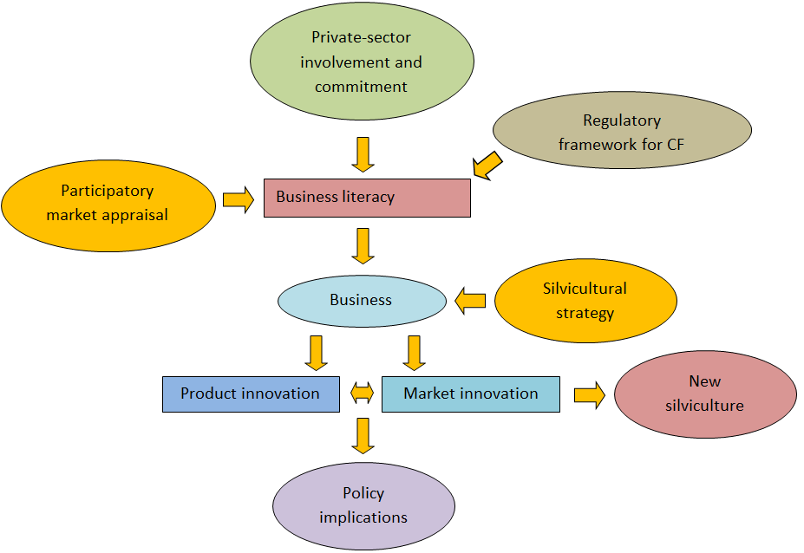
Appendix 4
Reflection from Visits to Nepal-Australia Forestry Project
Silviculture Trial Plots

Edwin Cedamon
13 March 2015

On the 6th and 7th of March, myself, Govinda, Madan and Khadga Kharel went on mission to visit the silviculture trial plots established by the Nepal-Australia Forestry Project (NAFP). The purposes of the visit are (1) to relocate the plots, (2) examine the potential for further re-treatments and (3) re-measure trees DBH and Heights for intact plots. The team was guided with a report of some trial plots archived from Khadga Kharel files. The report was titled “An Introduction of Forest Management Demonstration Trial Plots Sindhupalchok and Kavrepalanchok District” dated Jan 2003 with unknown author. The report indicated that 21 demonstration trial plots were established between 1983 and 1988. Summarised data and brief notes are available for the six of the 21 demo plots. Two of the demo plots –Forest Management Demo Plot and Sal Management Demo Plot in Sindhupalchok had data collected in 2005 analysed and reported by Roshan Thapa. Our team then embark on a mission to find at least the six sites with archived historical data.
Our findings from this mission is summarised in Table 1. Our visits revealed that Patlepani and Pipaldada plots are intact. Measurement of trees in Pipaldada was undertaken while measurement in Pipaldalda will be done later when a plot layout or knowledgeable person becomes available. Other plots with archived data could not be located.
Discussions with some CFUG members in Patlepani suggested that the some parts or the whole plot are included in a new demo trial plots established by DFRS were some trees were cut as part of the treatment. It has further been revealed that, learnings from the demo plots showed by the physical structure of the demo plots, i.e. showing provide evidence on how pine stand could support broadleaves, is not applied in the other area of the forest.
A technical paper describing the stand development under various treatments particularly for Patlepani Forest Management Trial and Pipaldada Sal Management Trial will be developed using pooled data from previous measurement. The paper will try to derive a diameter function based on tree height and stocking relationship of pine and broadleaves over 35 years and other timber stock described by the relationship. The same function will be derived from the Pipaldada Sal mgt trial plot. This function is hoped to be a robust predictor of tree growth on the same site quality.
Table 1. Summary of findings from visits to previous NAFP silviculture trials
Plot Location | Trial Plot Description | Findings
Dhulikhel | Forest management demo plots (3 plots) | Some concrete pillars installed on plot corners were found. Two plots are located in Dhulikhel picnic park and the other plot (plot 1-Favor pine plot) has about 60% located inside the army barracks (Figure 2). Some trees within the plots were cut indicated by stumps.
Dhulikhel | Shrubland demonstration plots (9 plots) | No pillars were found and therefore relocation of plots cannot be ascertained. The shrubland in now as dense-close canopy forest with predominant height of about 10 metres.
Patlepani | Forest demonstration plot (6 plots) | The plots were easily found because the trees were painted with white enamel last 2005 (Figure 3). The pillars however were found to be on wrong locations reportedly for another DFRS research. DBH and total height of observation trees were measured (see Annex one for the raw data).
Pipaldada | Sal management demonstration (6 plots) | Concrete pillars of some plots were found (Figure 4). Measurement of trees was not done due to lack of time. The team will return for measurement hoping to find/archive plot lay-out
Narayan Devi | Regeneration management plots (10) | Plots were not found due. The fencing materials which were hoped to be the plot markers were not found (Figure 5)
Sirchap | Borad leaves tree management demonstration trial | The plots were not visited due to lack of time. Observation of the plot form the road suggests that the plot has developed to a mixed broad leaves forest.
Sirchap | Grass management trial | The plots were found, although no pillars but the plots are still visible due to intensive grass collection. No data however exist for this plot.

Size of following images reduced from original document
Raw data of tree DBH and total height from Patlepani trial plots not included here

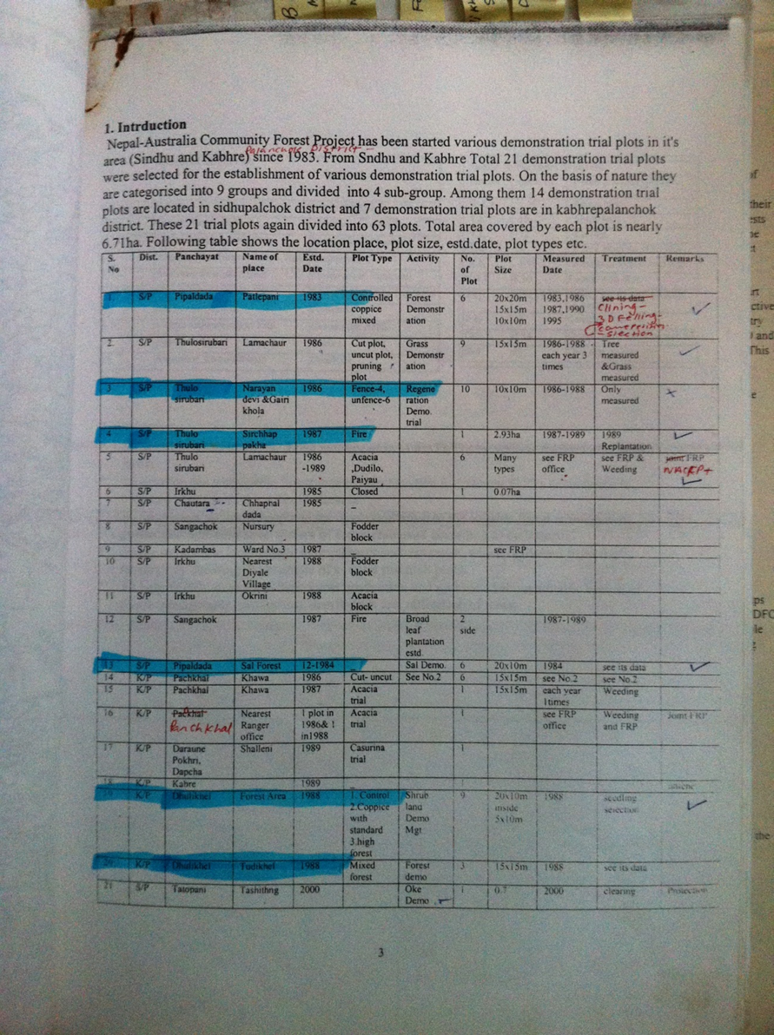
Figure 1. Summary of the Nepal Australia Forestry Project silviculture demo plots

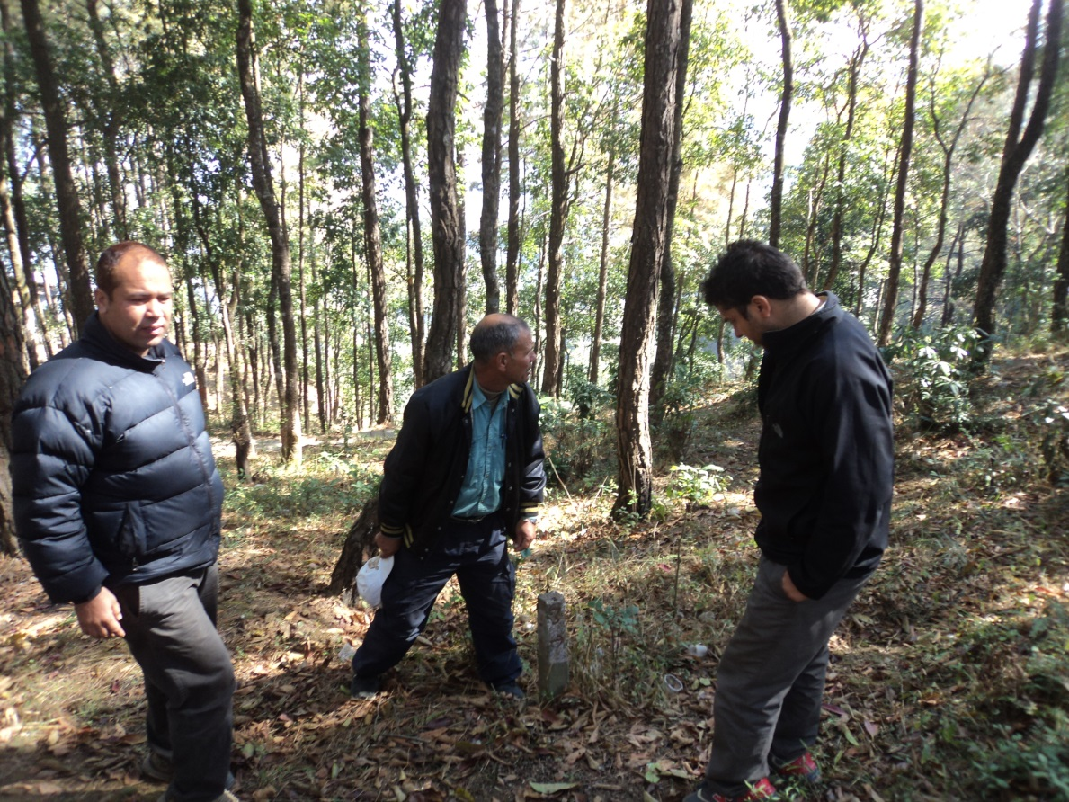
Figure 2. One of the three plots in Forest Management Trial in Dhulikhel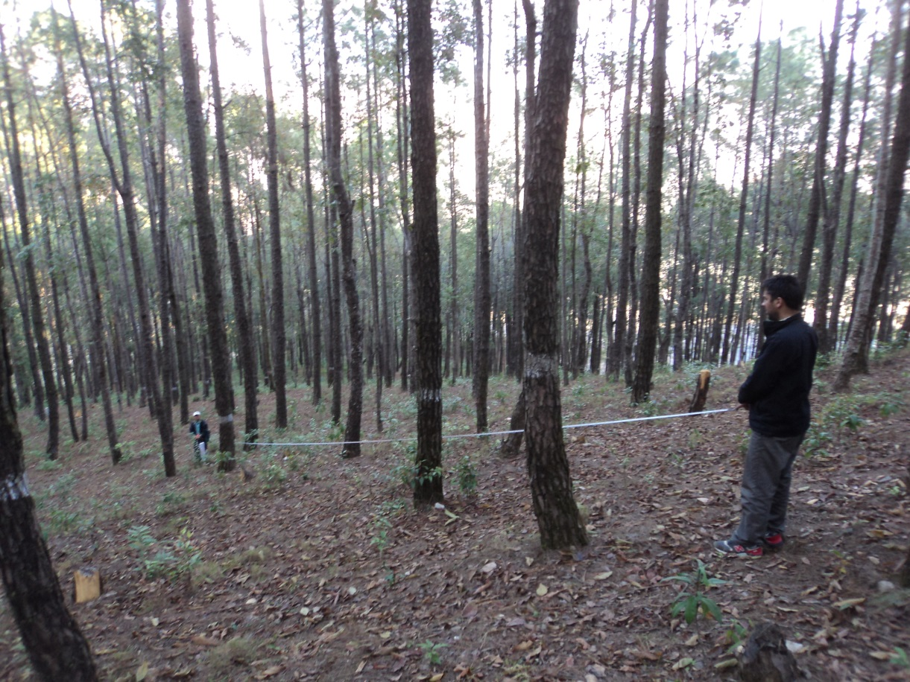
Figure 3. The EnLiFT Team relocating plots in Patlepani.
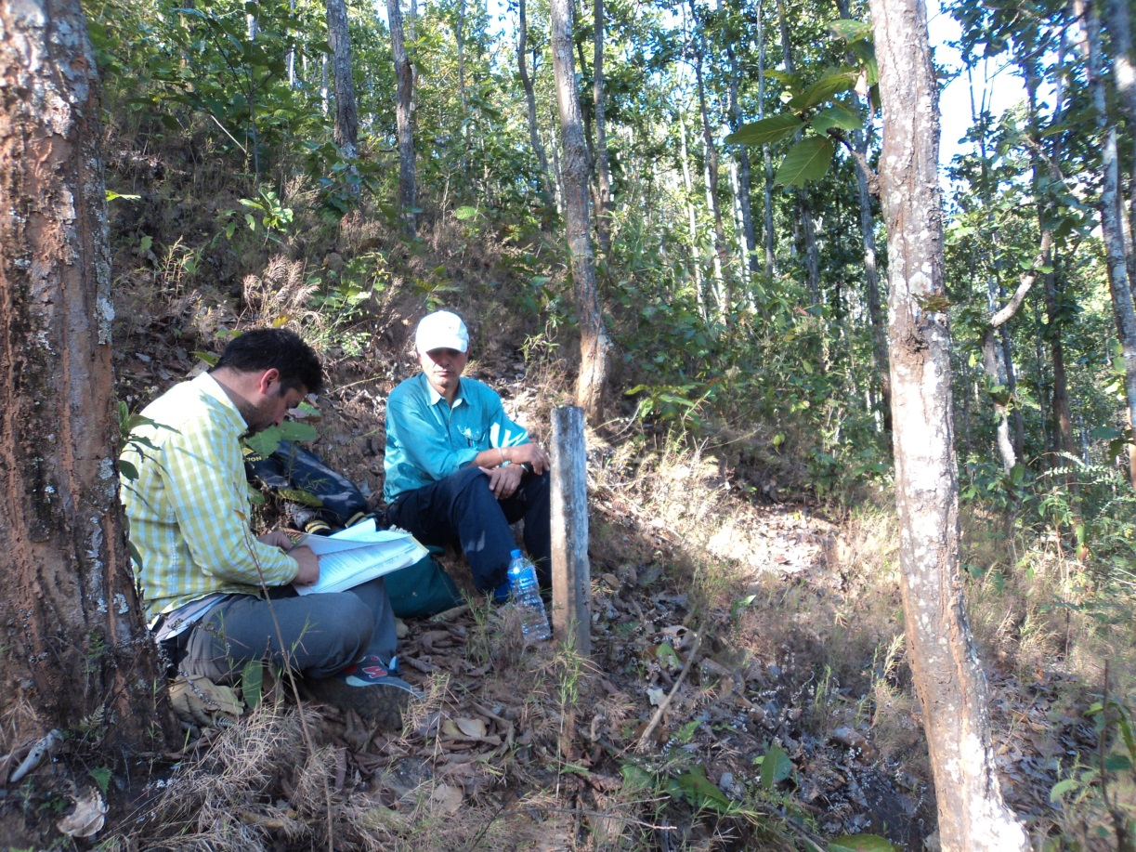
Figure 4. EnLiFT Team relocation plots in Pipaldada.
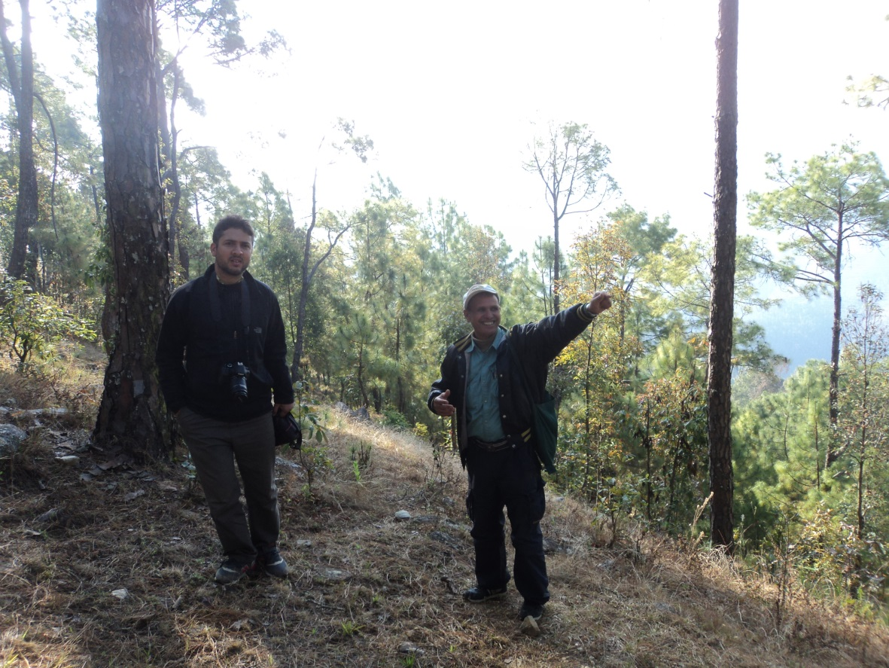
Figure 5. EnLiFT Team relocating plots in Narayan Devi

A paper on silvicultural characteristics and priorities is currently being prepared the authors
The definition of this acronym –silvics- is very fitting with this work. It is defined as the study of the life history, requirements and general characteristics of forest trees and stands in relation to the environment and the practice of silviculture (Gregorich, et al, 2001, Soil and Environmental Science Dictionary)
The absolute poverty line definition in terms of per capita income is NPR 19168 (US$ 200 approx). About 60 % (NPR 11500 or US$ 121) of this amount is used for consuming food products to meet daily requirement of 2226 calories. If the income is less than US$ 121 of a person, he or she is considered to be as hard core poor (NPC/CBS, 2011).

